EX.No. : 4

DML Commands with Constraints–UPDATE, DELETE

Aim:
To perform Data Manipulation Language (DML) commands such as UPDATE and DELETE on the Saveetha Hospital patient table.

Description:
DML statements are used for managing data stored in database tables. UPDATE modifies existing records, while DELETE removes records that satisfy a specified condition.
UPDATE syntax: UPDATE table_name SET column1=value1, column2=value2 WHERE condition;
DELETE syntax: DELETE FROM table_name WHERE condition;

Saveetha Hospital Dataset
Table: patients(patient_name, ward, treatment, doctor, operation, operation_fee)

Questions and Outputs

1. Update the treatment of the patient whose name is 'Ajay' to 'Heart Block'.
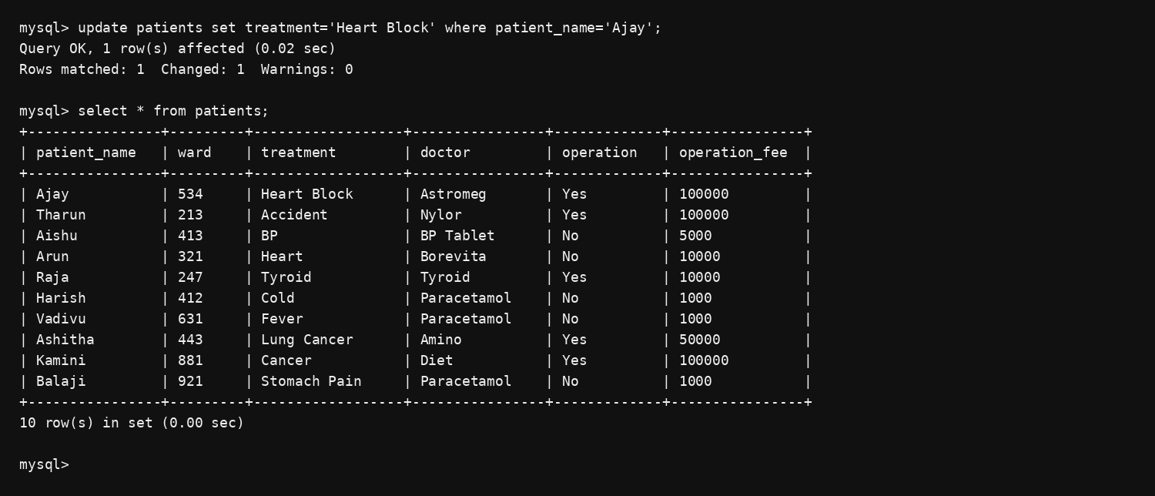

2. Delete the patients who have no operation.
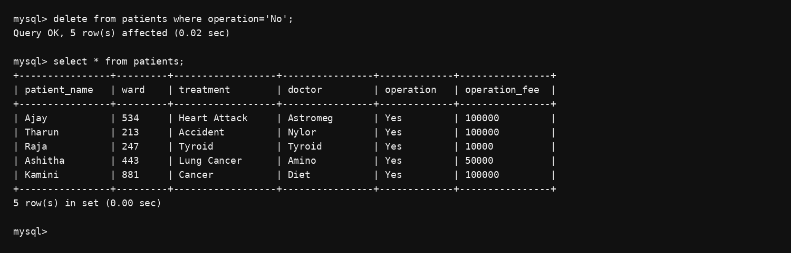

3. Modify the operation fee for the patient whose name is 'Raja' to 15000.
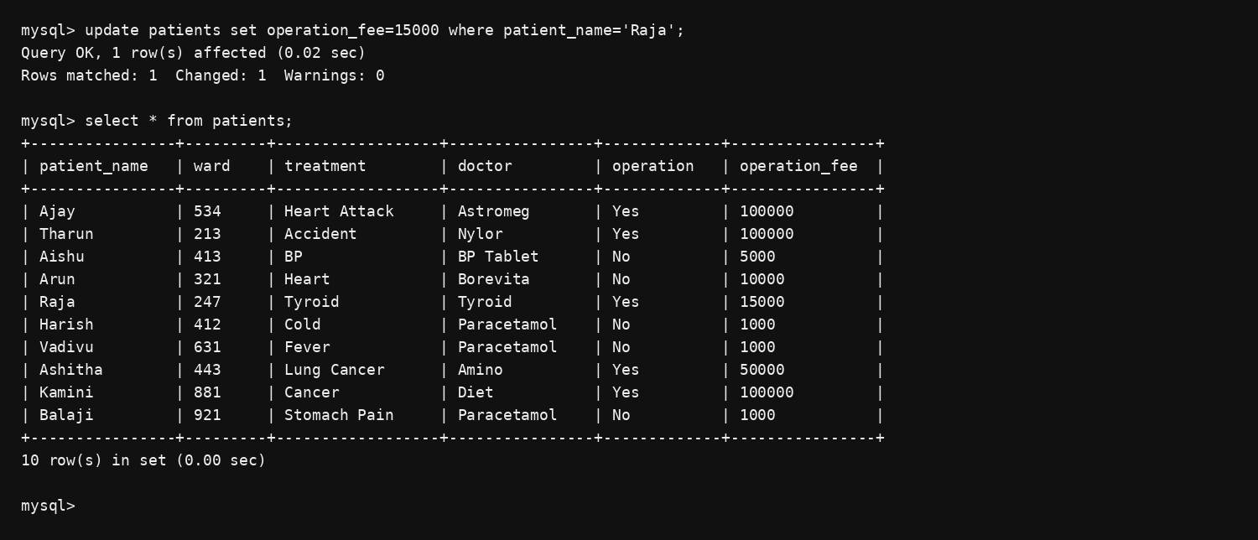

4. Remove all patients whose operation fee is greater than 65000.
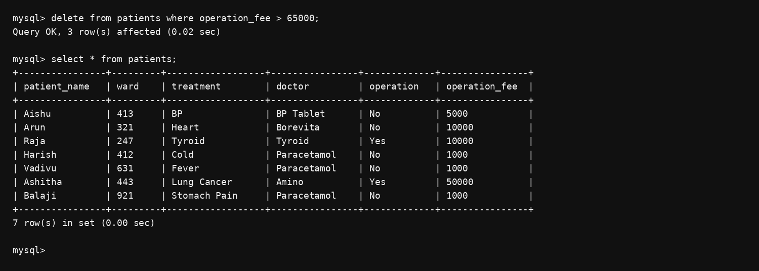
RESULT: UPDATE and DELETE DML commands are successfully performed on the Saveetha Hospital patient table.

